Brief History of Madison High School
Condensed from Louis Clements’ History of Madison High School
In 1923 the people of Rexburg came together and supported the development of a public high school. A bond was passed to build Madison High School, a sixteen room, red brick building on the northwest corner of Main Street and First West at the cost of $90,000.

In 1927 there were 80 students in the Sophomore class and 111 in the Freshman class. Junior and Seniors still went to the Ricks Academy. The first graduating class of Madison High School was in 1930.
In 1955 the Freshman class stayed in the red brick building as it became Madison Junior High, while the three upper classes moved during Christmas break into the two new grey brick buildings across the street to the east.

In 1973 a new high school was built on the east side of town on the northeast side of First North and Third East, at 134 Madison Avenue.
In 2010, continued growth in the community of Rexburg brought about the need for another new high school. In the fall of that year students moved into a larger campus west of the south entrance to Rexburg from Highway 20 at 2300 University Boulevard.
Madison High School students have always excelled in academics with hundreds of thousands of dollars being awarded each year in scholarships. An exceptionally high percentage of students go on to pursue higher degrees. The student body also excels in activities evidenced by a gym filled with State Championship Flags and a trophy case filled with awards in music, debate, and other activities. A testament to the leadership of the students at Madison is the many sportsmanship awards earned over the years.

A supportive community with a dedicated staff and faculty are the heart of what makes Madison High School students outstanding in the education community.

Madison built in 1926 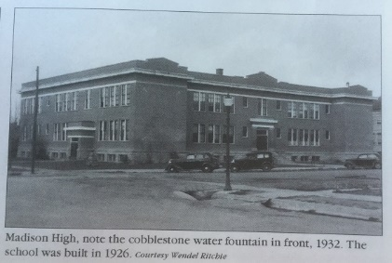  (Photo 1932) |  | Madison built in 1955  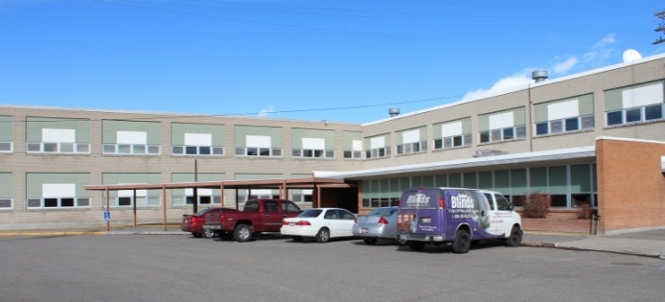  (Photo 2015)
Madison built in 1973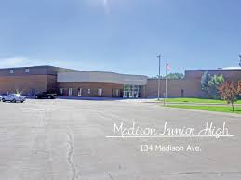  (Photo 2012) |  | Madison built in 2010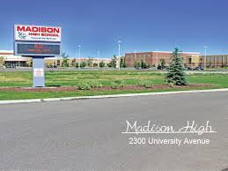  (Photo 2011)

